1. Write a view named InvoiceBasic that returns three columns: VendorName, InvoiceNumber, InvoiceTotal. Then, write a SELECT statement that returns all the columns in the view, sorted by InvoiceTotal from smallest to largest, where the first letter of the vendor name is A, B, or C.

Here is a query to create a view that returns three columns: VendorName, InvoiceNumber, and

InvoiceTotal.

CREATE VIEW InvoiceBasic

AS

SELECT VendorName, InvoiceNumber, InvoiceTotal

FROM Vendors JOIN Invoices

ON Vendors.VendorID = Invoices.VendorID;

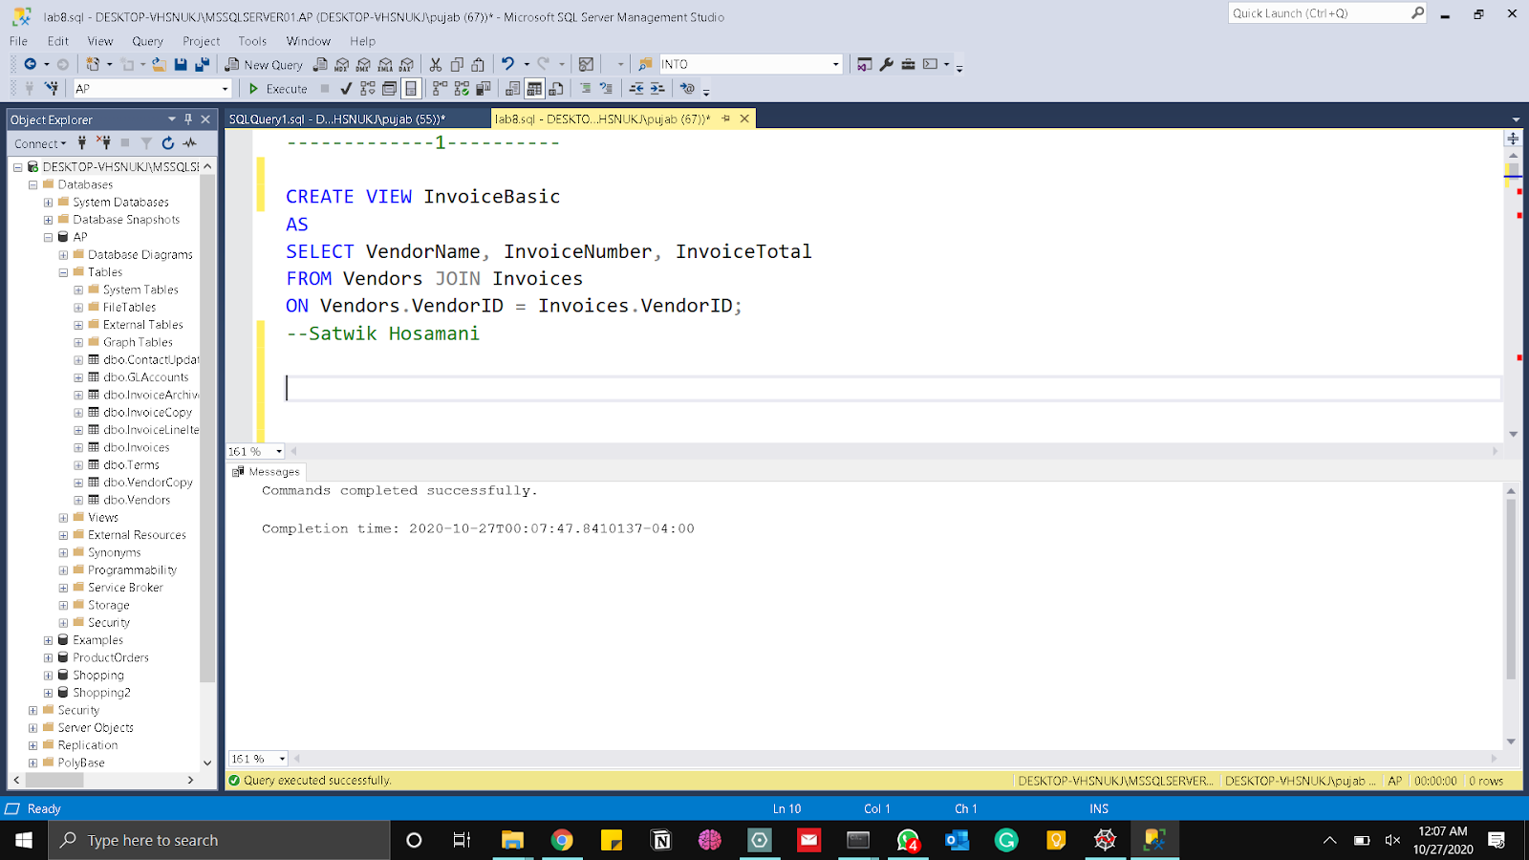

Here is the select statement that returns all the columns in the view, sorted by InvoiceTotal from smallest to largest, where the first letter of the vendor name is A, B or C.

SELECT *

FROM InvoiceBasic

WHERE VendorName LIKE '[A-C] %'

ORDER BY InvoiceTotal ASC;

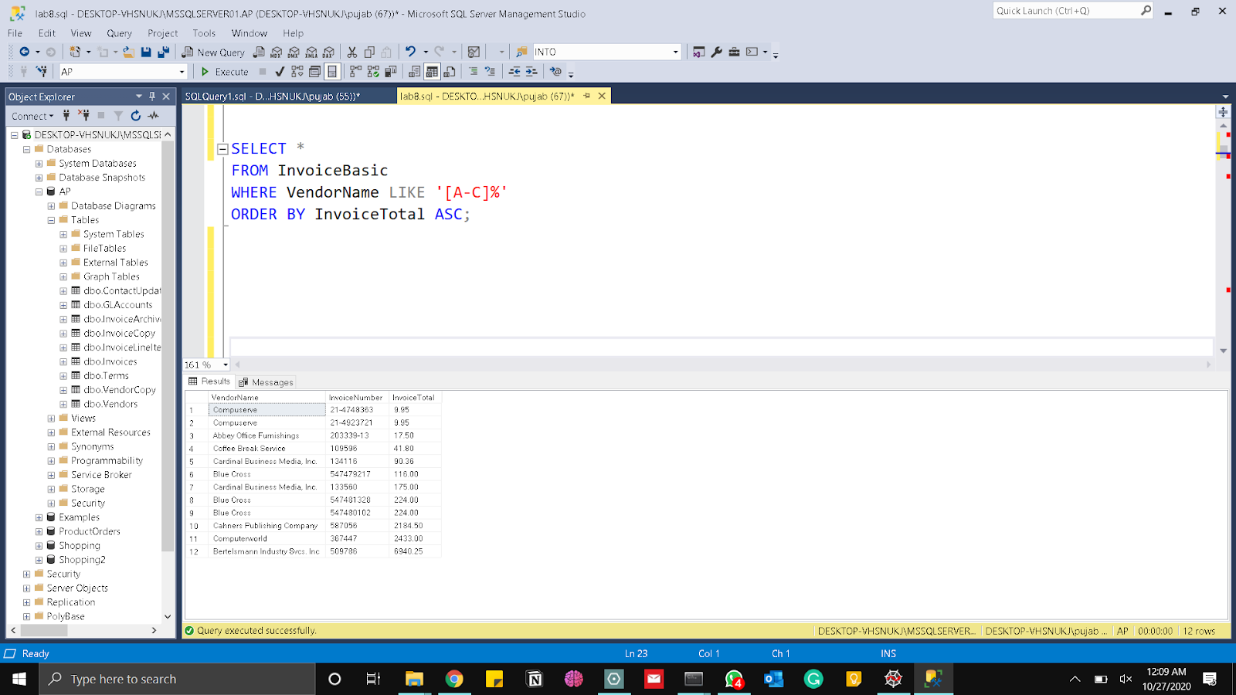

2. Create a view named Top10PaidInvoices that returns three columns for each vendor: VendorName, LastInvoiceDate (the most recent invoice date), and SumOfInvoices (the sum of the InvoiceTotal column). Return only the 10 vendors with the largest SumOfInvoices and include only paid invoices (i.e. InvoiceTotal - CredeitTotal - PaymentTotal = 0). Then write a SELECT statement to show results of the view.

Here is the query that creates a view named Top10PaidInvoices that returns three columns for

each vendor i.e. VendorName, LastInvoice (the latest invoice date), and SumOfInvoices(the sum of the InvoiceTotal column) that contained only the 10 vendors with the largest Sum Of Invoices and include only paid invoices (i.e. InvoiceTotal – CredeitTotal –

PaymentTotal = 0).

CREATE VIEW Top10PaidInvoices

AS

SELECT TOP 10 VendorName,

MAX(InvoiceDate) AS LastInvoice,

SUM(InvoiceTotal) AS SumOfInvoices

FROM Vendors JOIN Invoices

ON Vendors.VendorID = Invoices.VendorID

WHERE InvoiceTotal - CreditTotal - PaymentTotal = 0

GROUP BY VendorName

ORDER BY SUM(InvoiceTotal) DESC;

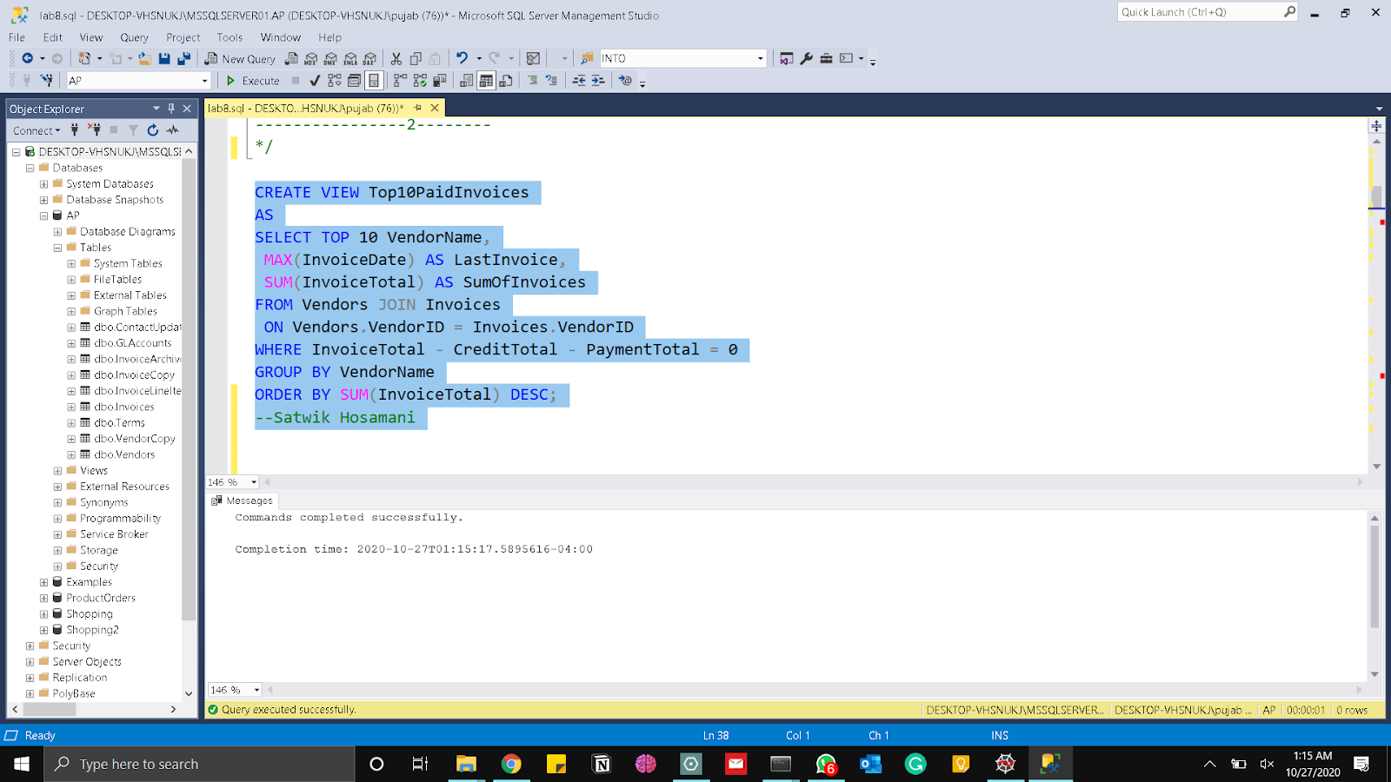

Here is the select statement that returns the results of the view

GO

SELECT *

FROM Top10PaidInvoices;

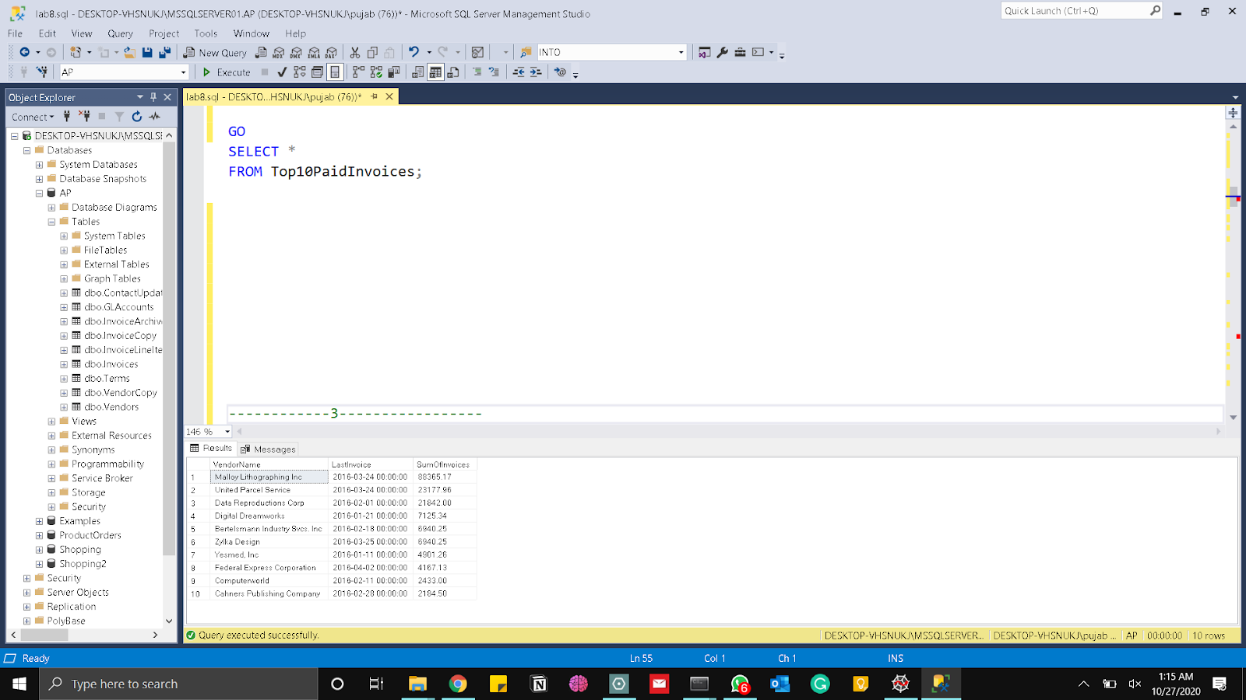

3. Create an updatable views named VendorAddress that returns the VendorID, Address (i.e. VendorAddress1 + ‘ ’ + VendorAddress2), and the city, state, and zipcode columns for each vendor. Whenever VendorAddress2 is NULL, substitute the NULL with a blank space. Then write a SELECT query to examine the result set where VendorID=7. Write a SELECT statement to verify the result.

Here is the query that creates an updatable views named VendorAddress that returns the

VendorID, Address (i.e. VendorAddress1 + ‘ ’ + VendorAddress2), and the city, state, and zip

code columns for each vendor.

CREATE VIEW VendorAddress

AS

SELECT VendorID, VendorAddress1 + ' ' + ISNULL(VendorAddress2, '') AS

AddressInformation, VendorCity, VendorState, VendorZipCode

FROM Vendors;

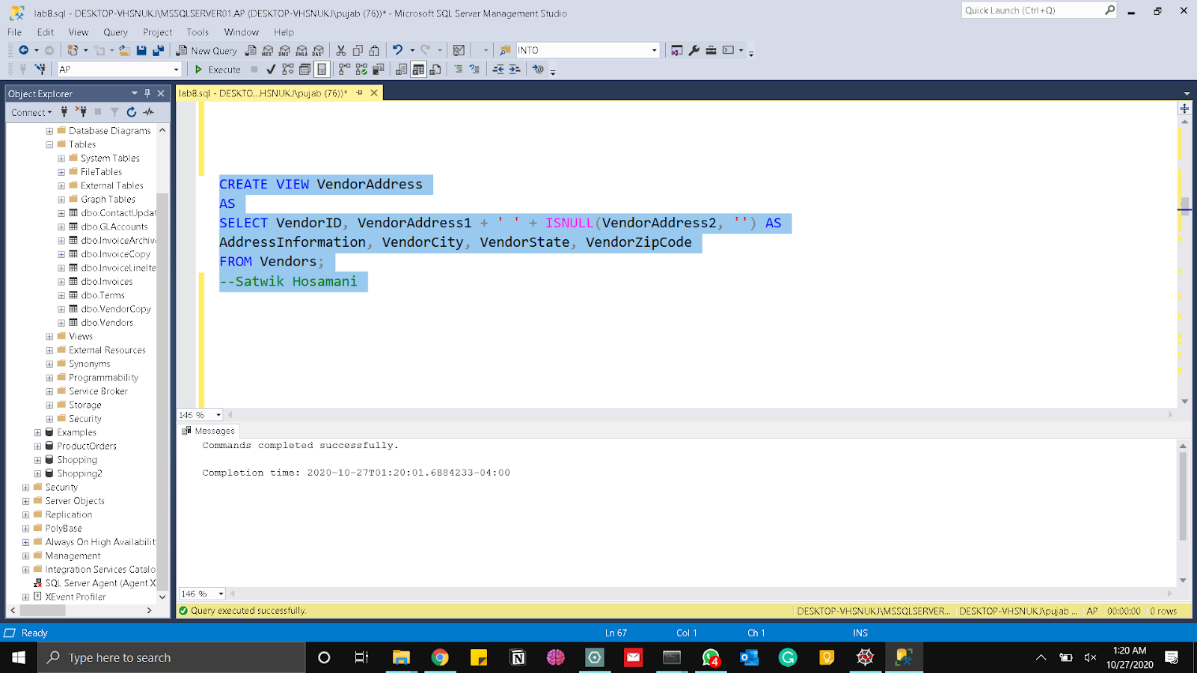

SELECT *

FROM VendorAddress;

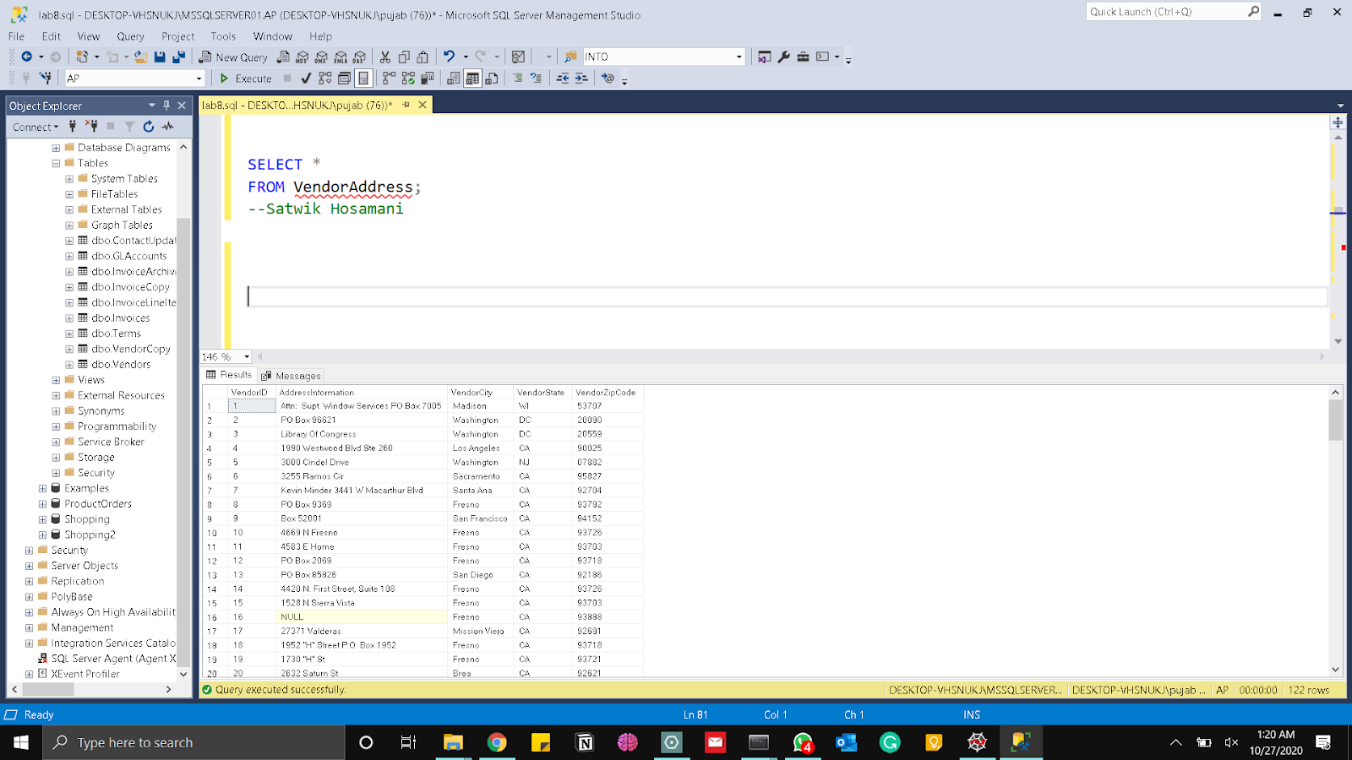

Go

SELECT *

FROM VendorAddress

WHERE VendorID = 7;

Here is the attached screenshot obtained after executing the above query and we have got one row for VendorID=7.

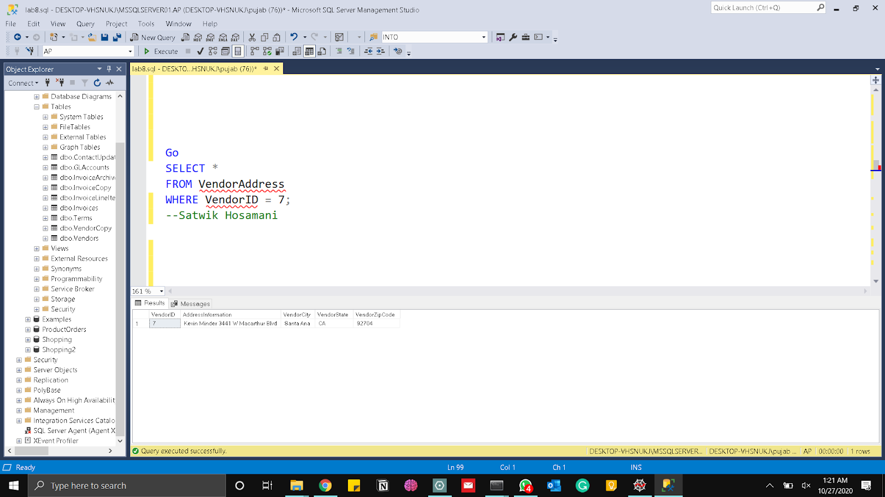

4. Write a SELECT statement that selects all the columns for the catalog view that returns information about foreign keys in the AP database. How many foreign key(s) is/are defined in the AP database and what is/are they?

USE AP;

SELECT *

FROM sys.foreign_keys;

Here is a SELECT statement that gives the foreign keys that are defined in the AP database

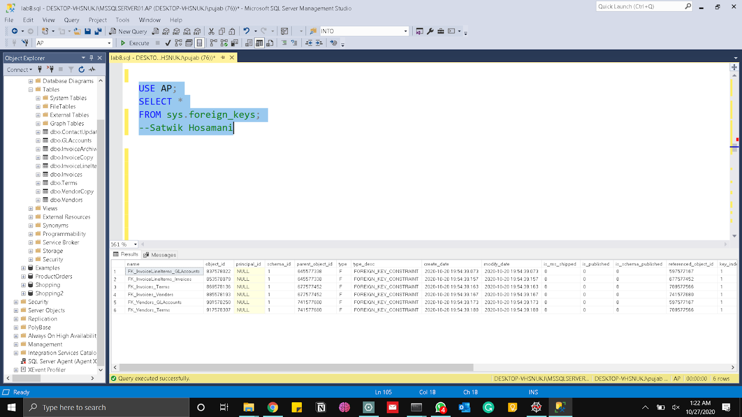

5. Write a script that declares and sets a variable named @TotalBalanceDue, which is equal to the total outstanding balance due. What is the datatype of the variable @TotalBalanceDue? If that balance due is less than $45,000.00, the script should return a result set consisting of VendorName, InvoiceNumber, InvoiceDueDate, and Balance for each invoice with a balance due, sorted with the newest due date last. Then also return the value of @TotalBalanceDue in the format of “Balance due is ...”. If the total outstanding balance due is more than $45,000.00, the script should return the message “Balance due is more than $45,000.00”.

Here is a script that declares and sets a variable named @TotalBalanceDue, which is

equal to the total outstanding balance due.

DECLARE @TotalBalanceDue MONEY

SET @TotalBalanceDue = ( SELECT SUM(InvoiceTotal - PaymentTotal - CreditTotal)

FROM AP.dbo.Invoices

WHERE InvoiceTotal - CreditTotal - PaymentTotal > 0)

IF @TotalBalanceDue < 45000

BEGIN

PRINT 'Balance due is ' + CAST(@TotalBalanceDue as NVARCHAR(15)) + '.'

SELECT VendorName, InvoiceNumber, InvoiceDueDate,

(InvoiceTotal - PaymentTotal - CreditTotal) AS Balance,

'Balance due is ' + CAST(@TotalBalanceDue AS VARCHAR(30)) AS '@TotalBalanceDue'

FROM AP.dbo.Vendors JOIN AP.dbo.Invoices ON Vendors.VendorID = Invoices.VendorID

WHERE InvoiceTotal - PaymentTotal - CreditTotal > 0

ORDER BY InvoiceDueDate DESC

END

ELSE IF @TotalBalanceDue > 45000

PRINT 'Balance due is more than $45,000.00';

Here is the attached screenshot obtained after executing the above query and we got 11rows.

Here is the attached screenshot of message obtained after executing the above query and Balance due is 32020.42

6. Explain the execution result generated by the following script. Then Write a script that generates the same result set but uses a temporary table in place of the derived table. Make sure your script tests for the existence of any objects it creates.

1. The following script uses a derived table to return the date and invoice total of the latest invoice issued by each vendor.

USE AP;

SELECT VendorName,LastInvoiceDate, InvoiceTotal FROM Invoices JOIN

(SELECT VendorID, MAX(InvoiceDate) AS LastInvoiceDate FROM Invoices

GROUP BY VendorID) AS LastInvoice

ON (Invoices.VendorID = LastInvoice.VendorID AND Invoices.InvoiceDate = LastInvoice.LastInvoiceDate)

JOIN Vendors

ON Invoices.VendorID = Vendors.VendorID ORDER BY VendorName, LastInvoiceDate

Here is the attached screenshot obtained after executing the above query and we got 34 rows.

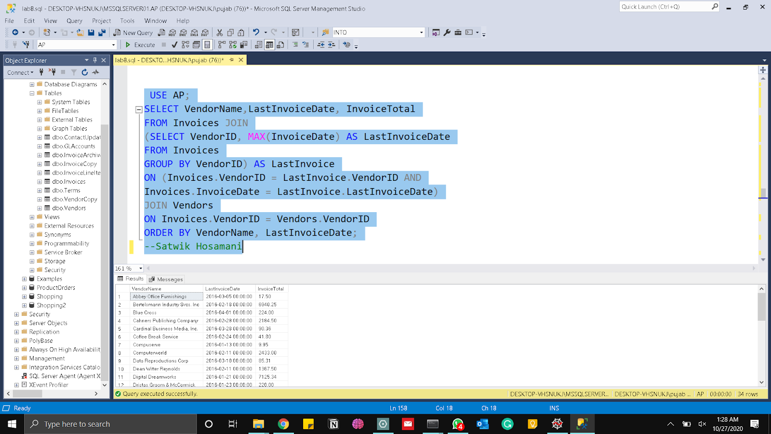

The following script uses a derived table to return the date and invoice total of the earliest

invoice issued by each vendor.

USE AP;

IF OBJECT_ID('tempdb..#LastInvoice') IS NOT NULL

DROP TABLE #LastInvoice;

SELECT VendorID, MAX(InvoiceDate) AS LastInvoiceDate

INTO #LastInvoice

FROM Invoices

GROUP BY VendorID;

SELECT VendorName, LastInvoiceDate, InvoiceTotal

FROM Invoices JOIN #LastInvoice

ON (Invoices.VendorID = #LastInvoice.VendorID AND

Invoices.InvoiceDate = #LastInvoice. LastInvoiceDate)

JOIN Vendors

ON Invoices.VendorID = Vendors.VendorID

ORDER BY VendorName, LastInvoiceDate;

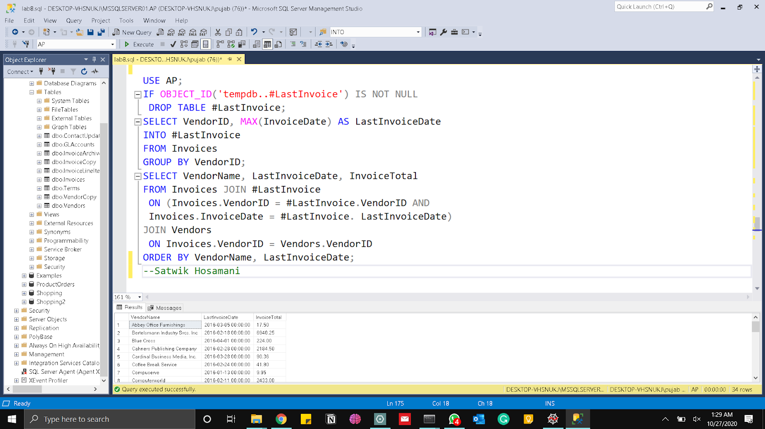

7. Write a script that generates the date and invoice total of the earliest invoice issued by each vendor, using a view instead of a derived table. Also write the script that creates the view, then use SELECT statement to show result of the view. Make sure that your script tests for the existence of the view. The view doesn’t need to be redefined each time the script is executed.

Here is a script that generates the date and invoice total of the earliest invoice issued by

each vendor, using a view instead of a derived table

USE AP;

IF OBJECT_ID('FirstInvoice_V') IS NOT NULL

DROP VIEW FirstInvoice_V;

GO

CREATE VIEW FirstInvoice_V

AS

SELECT VendorID, MIN(InvoiceDate) AS FirstInvoiceDate

FROM Invoices

GROUP BY VendorID;

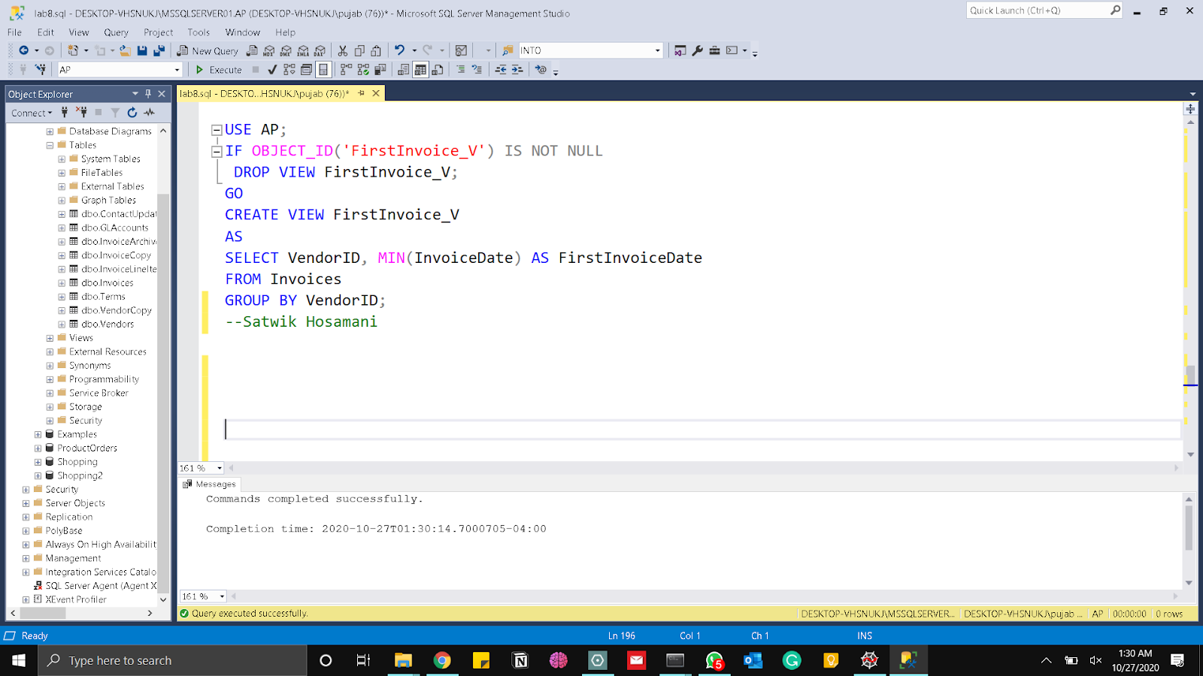

SELECT *

FROM FirstInvoice_V;

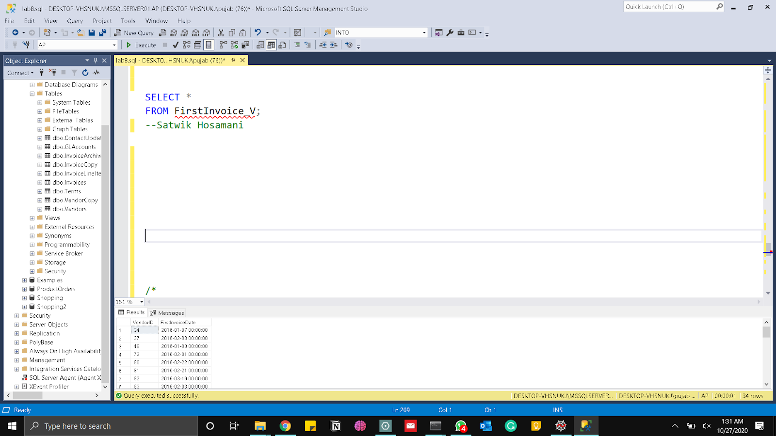

SELECT Invoices.VendorID, VendorName, FirstInvoiceDate, InvoiceTotal

FROM Invoices JOIN FirstInvoice_V

ON (Invoices.VendorID = FirstInvoice_V.VendorID AND

Invoices.InvoiceDate = FirstInvoice_V.FirstInvoiceDate)

JOIN Vendors

ON Invoices.VendorID = Vendors.VendorID

ORDER BY VendorName, FirstInvoiceDate;

Here is the attached screenshot obtained after executing the above query and we have 34 rows.

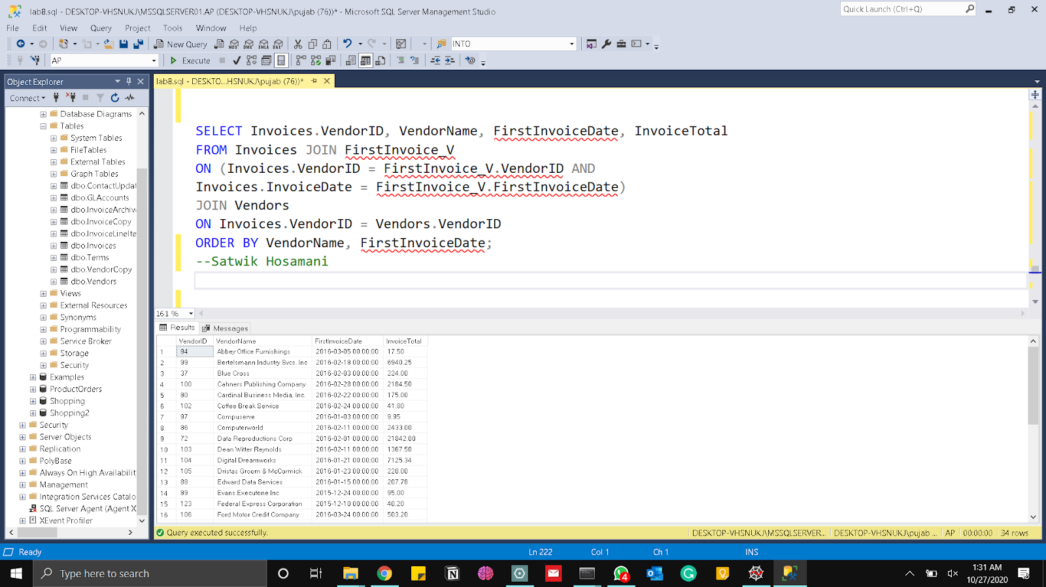

8. Write a script that uses dynamic SQL to return a single column that represents the number of rows in the first table in the current database. The script should automatically choose the table that appears first alphabetically, and it should exclude tables named dtproperties and sysdiagrams. Name the column CountOfTable, where Table is the chosen table name. Show results for AP database

Here is a script that uses dynamic SQL to return a single column that represents the number of

rows in the first table in the current database. The script automatically chooses the table that

appears first alphabetically, and it excludes tables named dtproperties and sysdiagrams.

It names the column CountOfTable, where Table is the chosen table name

DECLARE @TableName varchar(128);

SELECT @TableName = MIN(name)

FROM sys.tables

WHERE name < > 'dtproperties' AND name < > 'sysdiagrams';

EXEC ('SELECT COUNT(*) AS CountOf' + @TableName +

' FROM ' + @TableName + ';');

